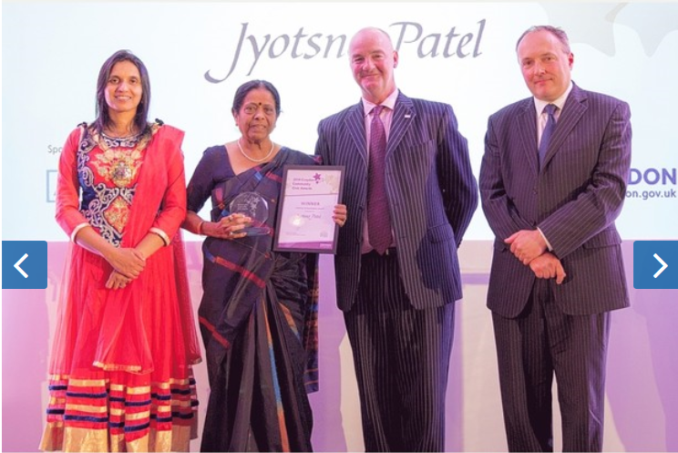

CROYDON'S unsung heroes have been recognised at an annual awards ceremony that celebrates outstanding volunteers in the community.
There were more than 150 nominations from the public for the third Croydon Community Civic Awards, which honours individuals and organisations that have gone the extra mile for others.
The 24 finalists who attended a ceremony at the Croydon Hilton Hotel on September 25 were judged by representatives of the voluntary sector and local business community.
The lifetime achievement award this year went to Jyotsna Patel, a 70-year-old Ugandan who arrived in the UK in 1972 and has been an active volunteer ever since.
For over 40 years, Jyotsna has helped people learn English, promoted healthy eating through her love of cooking, as well as organised a range of events to bring the young and old together.
"It's nice to be so appreciated – especially when you don't expect it to happen," said Jyotsna, who is now chair of the UK Asian Women's Organisation.
"I believe that working for people is in my blood," said Jyotsna. "Where my services are needed I will always give them.
"It makes me so happy to be busy the whole year helping and enjoying being with people," she said.
As well as the lifetime achievement award, accolades were given in the following categories: employees of the year, carer of the year, young volunteer of the year, civic life, personal achievement, voluntary group of the year, fundraiser of the year and volunteer of the year.
The Mayor of Croydon, Councillor Manju Shahul-Hameed, said: "Thousands of people volunteer in Croydon every year, and they enhance the community in which we live and work."
Judges examined each entry and scored achievements against criteria designed to identify those people who had gone further than others and made a real difference to their community.

